Uploading datasets and submitting to both faculty and university community
Researchers need to login.
Click on “New Upload” and upload a dataset or article.
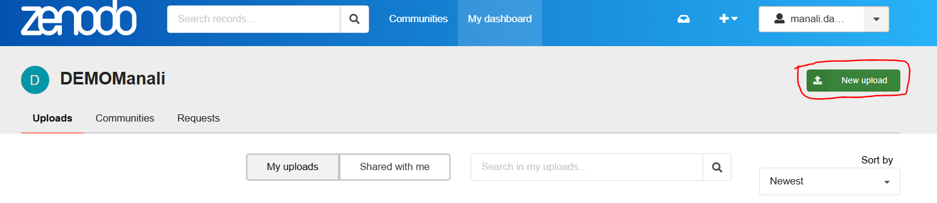
Once dataset is uploaded. Click on “My dashboard” to view the published dataset. Click on the dataset name to view the details.

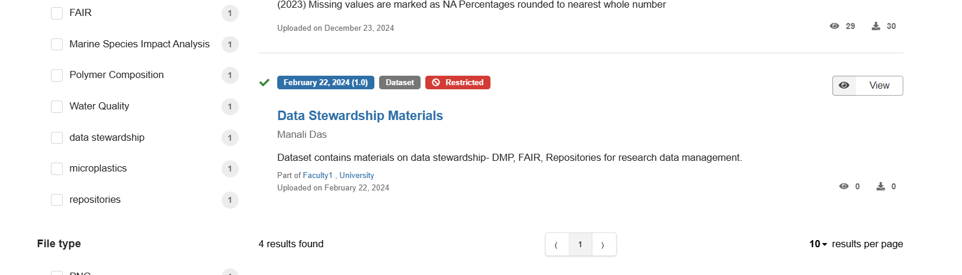
Go to communities on the right-side panel. Click on the dropdown and select “submit to community”.
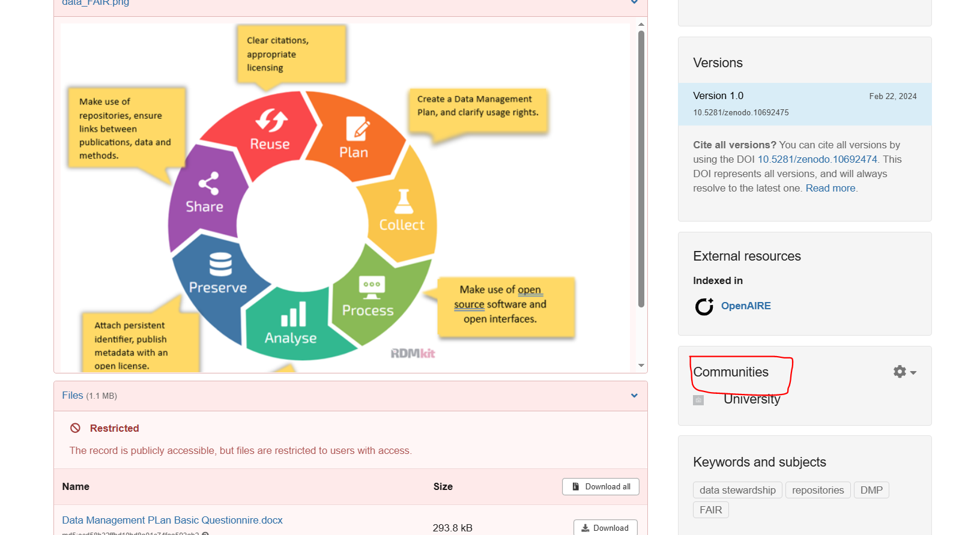
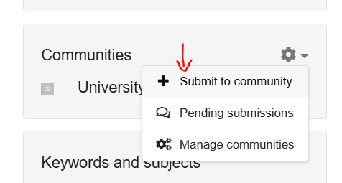

Search using your faculty community name and click on “select”.
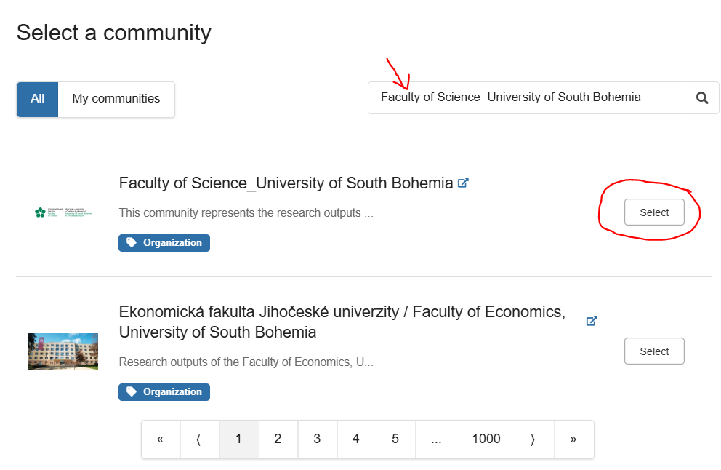

Select the checkbox, write any message and click submit to community.
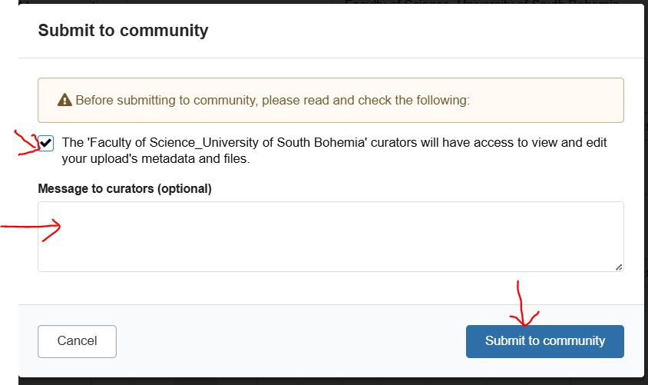

Search using the University community name “University of South Bohemia” and click on “select”. Click Submit to community.
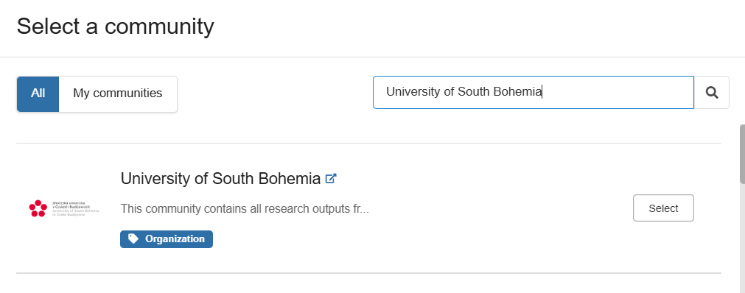
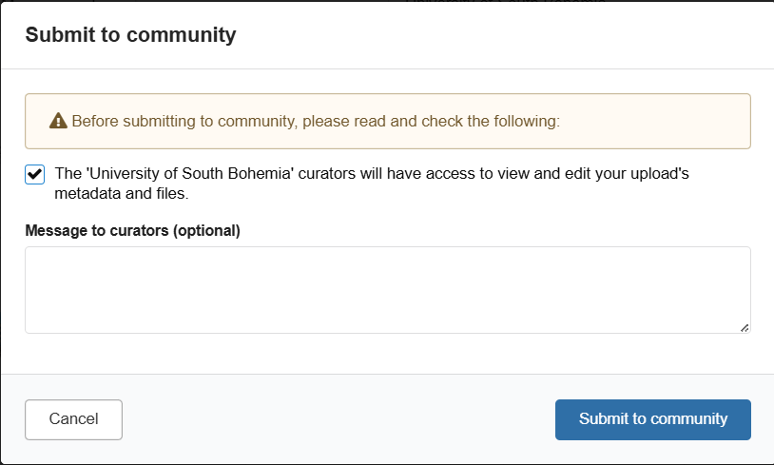

This will trigger an email to the community owner for approval.
